Lab - Region and Language Options (Instructor Version)

**Instructor Note**: Red font color or gray highlights indicate text that appears in the instructor copy only.

# Introduction

In this lab, you will examine region and language options in Windows.

# Recommended Equipment

* A computer running Windows

# Instructions

## Region Options

### Open the Region Tools.

* + - 1. Log on to the computer.
      2. Click **Control Panel** and view by **Category**. Click **Clock and Region** in Windows 10, **Clock, Language, Region** in Windows 8.1 and 7.
      3. Click **Region** in Windows 10 and 8.1. Click **Region and Language** in Windows 7.

### Explore the Region settings.

* + - 1. In the **Formats** tab, change the format in the **Format:** dropdown list. Note the examples at the bottom of the screen.
      2. Under the **Date and time formats** heading, change the format for the Long date using the drop-down options. Note the changes in the examples.
      3. Click **Additional settings**. What can you customize?

Type your answers here.

Answer may vary. Numbers, Currency, Time Date

* + - 1. Click **Cancel** to exit the Additional settings window.

## Language Options

In this part, you will install an additional language on Windows. After you are done with the additional language, you will remove the additional language. Furthermore, instructions for different Windows version are included in this part.

### Windows 10

* + - 1. Click **Language preferences** in the Region Window.

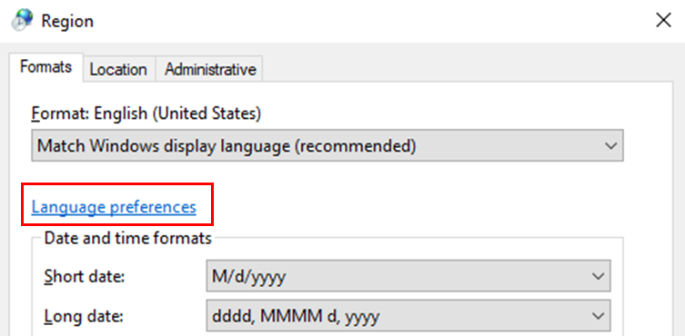

* + - 1. Click Add a language.
      2. Select the desired language. Click **Next** to continue.
      3. Notice the language features. Click **Install** to install the language package. This may take a few minutes.
      4. Under the **Windows display language** drop-down list, verify that default display language is correct. **Note**: Be careful when you choose a foreign language as the default display language.
      5. Close the Language window. Click **Cancel** in the Region window to continue.
      6. A language bar is now displayed on the taskbar. Click the **language** button to switch the keyboard to the additional language.

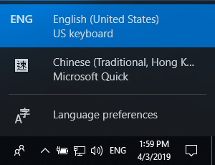

* + - 1. Depending on the additional languages, you will see one of the following changes in the Taskbar:

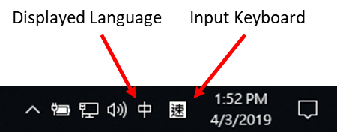 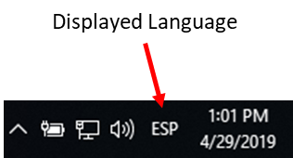

* + - 1. If you see both displayed language and input keyboard in the Taskbar, You can toggle between displaying the primary and the additional language. Click **Start** and search for the Control Panel by typing **Control Panel**.

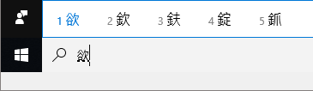

* + - 1. If only the displayed language icon is shown in the Taskbar or you want to change the default displayed language to an additional language, click the displayed language icon and select **Language preferences**. In the Settings window, under the Windows display language drop-down list, select the additional language. Log out and log back into Windows.

**Note**: If you were logged off the computer and a foreign language became the default display language, click the displayed language button in the taskbar. Select the **Language preference** option. Note the symbol associated with **Language preference** option.

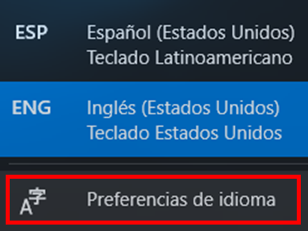

This will navigate you to the **Settings** window. Now select a default display language that you are familiar with in the drop-down box. Log out and log back into the PC.

* + - 1. Click **Start** > search for **Language** or click the **Language** icon in the taskbar and select **Language preferences**. Restore the default language as necessary. Log out and log back into Windows.
      2. Navigate to the language settings and select the additional language and click **Remove**. If you cannot remove the additional language because it is marked as the default language, click the down arrow and click **Remove** to remove the language.

### Windows 8.1

* + - 1. In the Region window, click **Language preferences**, then click **Add a language**.
      2. In the Add languages Window, select the desired language. Click **Add** or **Open** to continue. If there are regional variants in your selected language, select the language and click **Add** to continue.
      3. Close the Language window. Click **Cancel** in the Region window to continue.
      4. Click the **Language** bar. Now you can select between the default and additional languages.
      5. Select the keyboard for an additional language. Click **Start** > search for the Control Panel by typing **Control Panel** in the search field. The displayed language is for the additional language.
      6. The Language window can also be reached by navigating to **Control Panel** > click **Clock, Language, and Region** > click **Language** > click **Add a language**.
      7. Select the additional language that is not selected as the primary language and click **Remove** to remove it from the language list. If you want to remove the primary language, select the language and click **Move down**. Now you will be able to remove it.

### Windows 7

* + - 1. Select the **Keyboard and Languages** in the Region and Language window.
      2. Click Change keyboards.
      3. Click **Add** and select a language to add.
      4. Select a keyboard as necessary. Click **OK** to continue.
      5. Click the **Language Bar** tab. Verify that **Docked in the taskbar** is selected. Click **OK** to exit the Text Services and Input Languages window.
      6. Click **OK** to exit the Region and Language window.
      7. Right-click the **Taskbar**.
      8. Select **Toolbars > Language bar** to ensure that the Language bar is shown in the Taskbar.
      9. To remove the additional language via the Language bar, right-click the **Language bar** and select **Settings**.
      10. Select one of the installed input languages that is not selected as the default input language. Click **Remove** Click **OK** to continue.

# Reflection Question

* 1. Why would a user wish to change the input language of the operating system?

Type your answers here.

Answers may vary. Someone may be bilingual and wish to use a second or third language as the primary source of input. Someone also may not understand the primary input language and wish to use the one that is native to them.

* 1. How would a user easily switch between multiple installed languages within the operating system?

Type your answers here.

Answers may vary. Use the taskbar language button or the Windows display language dropdown in Language Preferences.

End of Document